

BULACAN HALAL ECOSYSTEM

DEVELOPMENT CENTER

A Proposal

**FAST FACTS:** *Global Halal Trade = US$2.67 Trillion; ASEAN Halal Market = US$1.38 Trillion; Philippine Halal Market Potential = US$400 Billion (Philippine Halal Export Development and Promotion Board).*

**BULACAN** has an estimated Muslim population of 95,000 with its leaders actively engaging in nation building, and particularly, supporting the Muslim-friendly Administration of Governor Daniel Fernando. With its vigorous leadership in the Bulacan Muslim Affairs Consultative Council (BMACC), the Governor is now in the best position to spearhead a model Halal Ecosystem and develop all its local potentials to become the center-stage for stimulating the Philippine Halal Market Potential of US$400 Billion.

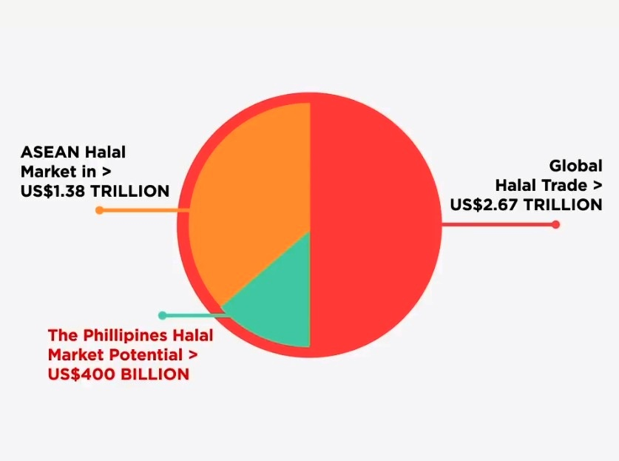

In this light, it is hereby proposed that the BMACC shall create a Special Task Force funded by the Office of the Governor to conduct activities leading to the creation and operation of a Bulacan Halal Ecosystem Development Center, a prototype of a complete halal hub in Central Luzon.